Key points for students
The Scratch website can be found at https://scratch.mit.edu/.
To begin a new project click on ‘Start Creating’:

Blocks are arranged in categories on the left-hand side of the screen.
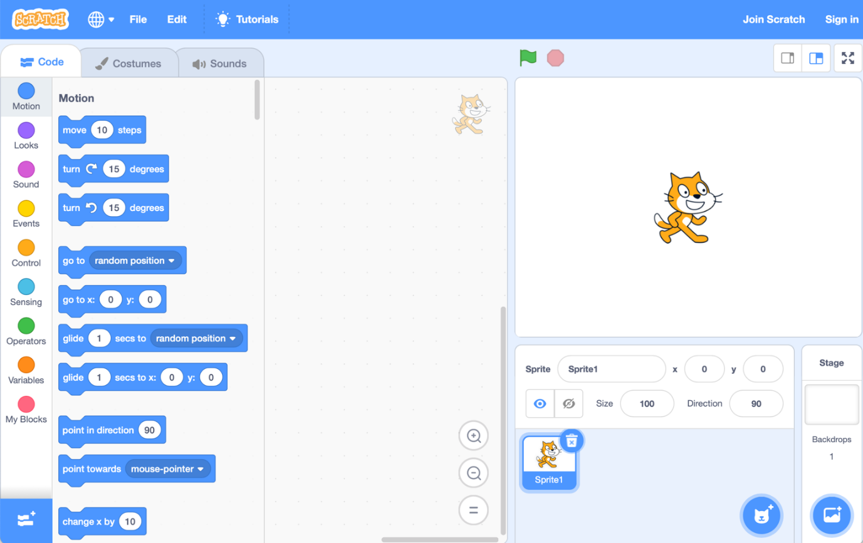
To use a block, click on it and drag it to the coding area in the centre.
Extensions, such as the ‘Pen’ can be added by clicking on the icon in the bottom left-hand corner and choosing the extension required.
Drag and drop the code blocks to join them together. If a code block is no longer needed, drag it to the left, out of the coding area.
To run a program click on the green flag. To stop a program before it has finished running click on the red octagon.


To save your program, click on ‘File’ and then select ‘Save to your computer’.
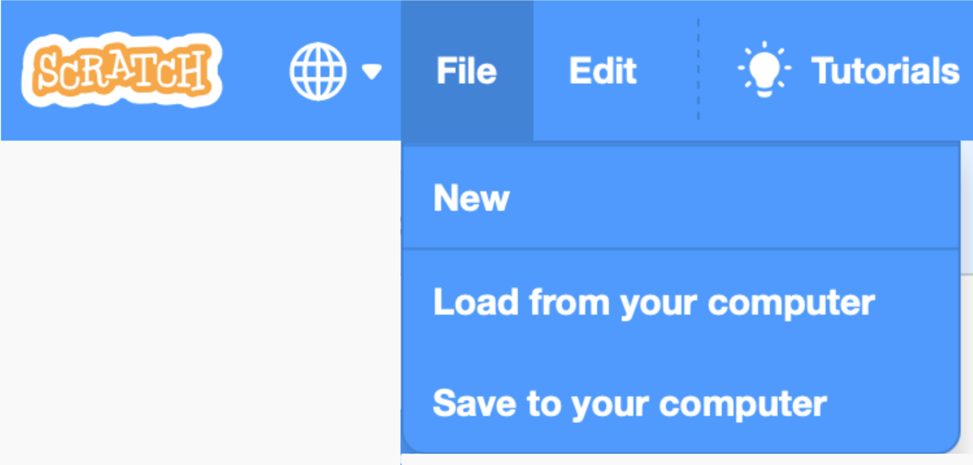
The program will usually be saved to your downloads folder.
To re-open a saved program, choose ‘Load from your computer’ and locate the file.

